Experiment 3: Distillation of Whiskey Flavouring Compounds

Overview:

Whiskey, a popular alcoholic beverage, has a unique taste shaped by its flavouring compounds. Taking a closer look, it is the different organic compounds and functional groups within them that are responsible for these distinct flavours. Propionaldehyde and 2-propanol are two of many flavouring compounds present in whiskies (Figure 1), which have an almond/apple/banana and butter aroma respectively.
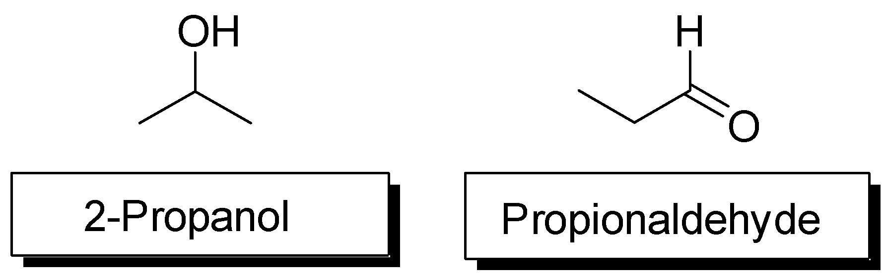
Figure 1. The structures of 2-propanol and Propionaldehyde

Distillation is a method of identifying and purifying organic liquids. For instance, the boiling point of a compound, and hence its identity, can be determined by distillation. Since a chemical’s boiling point is a well-defined physical property, distillation can also be utilized to separate the solution as a means of purification, given that each of the components have different boiling points.

How are the walls of the condenser kept
cool?

Why slow and steady?
“Distillate" and “condensate” may be used interchangeably.
As a liquid solution is heated in a distillation apparatus, the vapour pressure of the liquid (the tendency for the molecules to escape from the surface) increases until it is equal to the atmospheric pressure. At this point the liquid is said to be boiling. Additional heat supplied by further boiling provides the energy necessary for conversion of the liquid phase to the gaseous phase. Distillation is a process of boiling a liquid to vapour, then re-condensing the vapour back to a liquid, called the distillate. The vapour will rise in the apparatus and, in time, warm the distillation head and the thermometer before flowing down the condenser. The cool walls of the condenser remove heat from the vapour and condenses it back to a liquid form called the condensate, or distillate (see Figure 2).

Distillations should always be carried out slowly and steadily to ensure that the liquid and vapour remain in equilibrium. When this situation has been attained, the column of vapour will rise slowly up to the thermometer bulb and a small drop of liquid will condense on the bulb. This drop of condensate should remain on the thermometer throughout the distillation, constantly bathed by the flow of vapour. The temperature of the vapour at the distillation head will then be the "true" boiling point of the liquid being distilled. If too much heat is applied, the liquid will be superheated and the equilibrium will be lost. As a result, the vapour composition will change, becoming richer in the component of the mixture with the higher boiling point. If superheating occurs, the drop of condensate will disappear. Rapid distillation will carry the system away from equilibrium resulting in poor separation of the volatile components. Therefore, keep in mind that the slower the distillation will yield better results.

This experiment is comprised of two parts. In the first part you will be performing simple distillation of an unknown liquid. From the boiling point obtained in your simple distillation, you can determine the identity of the unknown.

In the second part of the experiment, you will carry out a fractional distillation on a solution of unknown liquid and water to determine the percent composition of the unknown solution. For your fractional distillation, it will be important to figure out if you are distilling an azeotrope. In an azeotrope, the composition of the miscible liquid is the same as the vapour; this poses issues for distillation since it operates on the compositions of the liquid and vapour being different. This means that with an azeotrope, the components of the liquid cannot be separated from each other.

An azeotrope will act as a pure liquid instead of a mixture and have all the components distill at a single boiling point, which will differ from the individual boiling points of each liquid in the mixture.

If the solution does not form an azeotrope, then the liquid will distill at approximately the same temperature as the boiling point of the pure unknown. If an azeotrope forms, then the boiling point of the first fraction may, or may not be different. If the boiling point differs, this will be the first clue that you are distilling an azeotrope. You will also obtain your partner’s results and analyze their data. Construct a graph of temperature versus distillate volume for each distillation (using your data, as well as other groups’) using the graph papers provided. Before coming to the lab, think about what this graph should look like. Have all four graphs initialed by your TA before leaving the lab. From the graphs, determine the boiling point of the unknown liquid, the identity of the unknown liquid, and the percentage composition of your assigned solution. From this information you should be able to determine what whiskey type you were given for distillation. Enter the information on the Data Sheet provided and hand this all in with all the graphs at the beginning of your next lab period (Before the quiz!).

In this lab, you will be distilling one of the compounds listed in Table 1, as well as its mixture with water. You must check section D of the CRC Handbook (available through the library resources on our course Quercus page) to find out which (if any) of these compounds may form an azeotrope (with water), and the composition of any azeotrope that forms. You must do this before coming to the lab!
Table 1. List of possible compounds and their boiling points
Compound | Boiling point
2-Propanol | 82 °C
Propionaldehyde | 48 °C

Once you determine the components of your mixture, you will match the whiskey they are present in and determine what type you were given (Table 2).

Table 2: List of whiskeys and the flavouring compounds found in them
Fictional Whiskey Name | Flavoring Compounds
Gatsby’s Willow | 2-Propanol + Propionaldehyde
Lion’s Tail | 2-Propanol (+ Water)
Barringtons | Propionaldehyde (+ Water)

Using your plotted graph of temperature vs volume, you must find the percent composition of the flavouring compounds of the whiskey.

To calculate percent composition, you must search percent by weight composition for azeotropes you may be using ahead of time. The formula for percent composition:

$$\frac{amount of distillate collected}{total initial volume}× (ratio of one component)\% × 100$$

For the boiling points recorded in fractional distillation, you must correct them based on the atmospheric pressure.

How to Calculate Corrected Boiling Point:
- Determine the current atmospheric pressure in mmHg (you can use the weather app on your phone)
- Boiling Point Correction Factor (°C) = $\left(\frac{760 torr-atmospheric pressure}{10 torr}\right)×0.5$
- Corrected Boiling Point (°C) = Observed Boiling Point + Correction Factor

Before beginning this experiment, read the section entitled “Liquids," found in the Appendix. Three basic types of distillation are outlined there. (We will not be doing a Co-distillation in this course.)

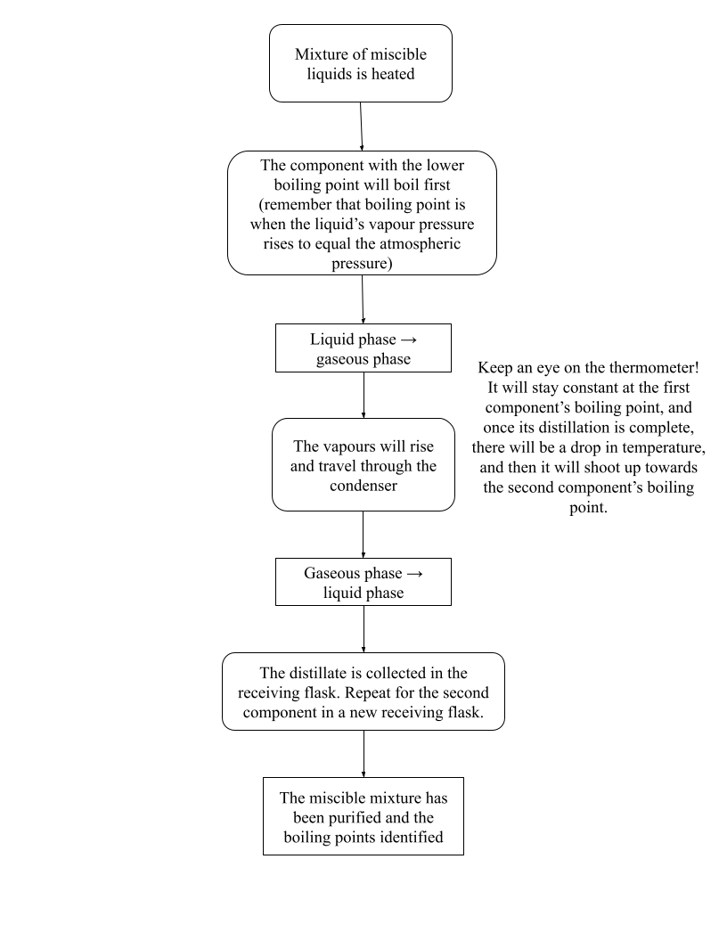
Figure 2. Distillation Step-by-Step Walkthrough

For both simple and fractional distillation, you must not distill to dryness!
You will be working in pairs. Each group should hand in one set of graphs and data sheets

Experimental Procedures:
Simple Distillation: For set-up, refer to Figure 3

- Put two retort stands that will support both ends of your distillation setup into your fume hood. Set up a lab jack and heating mantle.
- Pour 22mL of pure unknown (A or B) into a 50mL round bottom flask, along with some boiling chips. The RBF should be filled no more than 2/3, and no less than 1/3 its capacity. Why?
- Clamp the neck of the 50mL round bottom flask to the retort stand that is on the side of the hot plate and adjust the lab jack for the heating mantle to touch the flask. Make sure that the flask has good contact with the mantle for maximum heating efficiency (if flask smaller than mantle, insulate around the flask with aluminum foil). Make sure that the clamp length is adjusted so that the remaining apparatus will be vertical.
- Put grease onto all joints (Your TA will demonstrate how to do this).
- Connect the distillation head to the round bottom flask. Insert the thermometer adaptor into the top of the distillation head and twist the thermometer into the thermometer adaptor. The top of the thermometer bulb should be a little bit below the side arm of the distillation head (See Figure 3b).
- Attach the condenser joint to the distillation head, while the clamp is slightly loose. If one hand is holding the condenser, the other can be moving and tightening the clamp. The joints should fit together well without force and there should be no possible leak. If the joints do not fit together properly, or the apparatus is no longer vertical, then check the height of the condenser clamp. Once this is done, tighten the clamp.
- When you are satisfied, place the glass adapter on the end of the condenser, stretching the elastic from the bottom water inlet of the condenser to prevent the adapter from falling off the end of the
- Tighten the clamp around the condenser if not done in previous steps.
- Connect the condenser to both the distillation head and adaptor. Remember to grease all joints. Place an elastic band around the bottom water inlet of your condenser and attach the other end to glass adapter at end of condenser.
- Put a graduated cylinder under the adaptor to collect the distillate.
The joints of your distillation apparatus should connect well without any leakage
- Ask your TA to check your distillation apparatus before you proceed. Once your TA has approved your set up, turn on the water faucet slowly (green tap) then proceed heating on a high setting until boiling begins.
- Once boiling has begun, adjust the heat on the heating mantle until the distillate collects at a rate of about 1mL per 1.5-2 minutes (keep the temperature steady). Remember to regularly check that the drop of distillate has formed on your thermometer bulb.
- In your notebook, record the temperature given on the thermometer and total volume collected at regular intervals (every 1mL of distillate formed).
- When finished, turn off and lower the heating mantle to allow the flask to cool until it can be handled safely and discard any remaining liquid in the “chemical waste” bottle in your fume hood.
- You can plot your simple distillation graph while your fractional distillation is heating up.
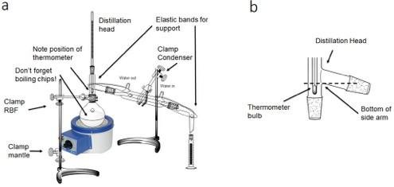
A: Diagram of the simple distillation apparatus
B. Correct position of the thermometer inside the distillation head. The thermometer bulb must be entirely below the bottom of the side arm

Figure 3. Simple distillation set-up

Fractional Distillation:
- Obtain 22 mL of your assigned unknown solution A or B (this is NOT the same sample that you used for simple distillation! It will be in a different bottle) and add boiling chips.
- Transfer the new unknown solution assigned by your TA into a new 50mL round bottom flask and add boiling chips into it.
- Collect a fractionating column and edit the distillation apparatus as in Figure 4. Insulate the round bottom flask and column with aluminum foil up to the thermometer bulb. Make sure that the joints in the apparatus are still well-connected.
- Have your TA check your fractional distillation apparatus.

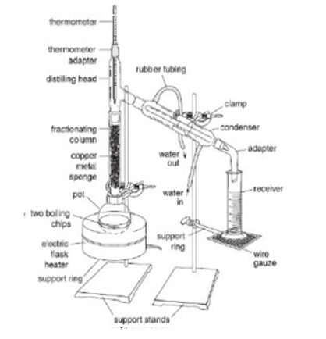
Figure 4. Fractional distillation set-up

- Begin heating and bring the solution quickly to a boil. As soon as boiling begins, turn down the heat supply, but maintain boiling. You will be able to feel the fractionating column heat. If carried out properly, it will take several minutes for the condensate to reach the top of the column.
- Once distillation has begun, it should continue steadily, without any rise or drop in temperature and at a rate no greater than 1 mL in 1.5-2 minutes. If no azeotrope forms, the temperature should be at the boiling point of the pure unknown; if an azeotrope does form, then the boiling point may differ.
- Observe the flow and keep it steady by adjusting the heat setting to obtain equilibrium and the required results of a steady temperature. From the boiling point obtained from your simple distillation, you should have figured out the identity of your unknown liquid. Keep this in mind when adjusting the mantle setting.
- Ensure that you record the temperature at which the first drop of distillate comes into your graduated cylinder. Record the temperature and volume of total distillate for every 1 mL until the first lower boiling component has completely distilled and you see a sudden jump in temperature. Keep in mind the boiling point of any possible azeotropes and that you may have to increase the heat on the heating mantle to keep the distillation active.
- At this point, you are expected to have identified the components of your solution or if you had an azeotrope (and if so, the components of the azeotrope).
- Plot the fractional distillation graph and complete the data sheet. Determine which whiskey uses the flavouring compound(s) in your mixture (refer to Table 2). Have this ready by the end of the lab.
- When finished, discard the distillate and residues into the waste chemical bottle provided in the fume hood. Return used aluminum foil to the front of the lab.

Pre-lab questions:
- If you are carrying out fractional distillation and do not have a mixture that forms an azeotrope, what do you expect to see when you plot your graph?

- What is the purpose of a fractional column? How does it work?
- In the apparatus, what’s the most important piece to be clamped, and why?
- What’s a theoretical plate? Why is it used? (Hint: Refer to the “Fractional Distillation” section in the Appendix!)
- Why should a distillation be done relatively slowly, rather than as quickly as possible?
- Why is the position of the thermometer important in a distillation apparatus?
- What is the direction of water flow in a condenser? What would happen if the water ran through the condenser in the opposite direction?
Post Lab Questions:

- Suppose you had chemical A with a boiling point of 150°C and chemical B with a boiling point of 115°C. What is the process you would use to separate these two compounds?
- Why are azeotropes important? Cite any sources you use.
- Components A and B form an azeotrope at 30% A and 70% B. The total volume of the mixture of A and B used for distillation was 22mL. If you distilled 4mL, what is the percent composition of A? Of B?

References:
      - Wan, H;, Djokic, N.; Brown, B. A; Kwon, Y. Using Whiskey-Flavoring Compounds To Teach Distillation and IR Spectroscopy to First-Semester Organic Chemistry Students. J. Chem. Educ., 2014, 91 (1), 123-125. DOI: 10.1021/ed300718y
      - https://www.homepages.ed.ac.uk/jwp/Chemeng/azeotrope/WW.html#Water (accessed Aug 19, 2024)

Data Sheet for Experiment 3 – Distillation of Whiskey Flavouring Compounds
To be handed in with two graphs. [One your own, one of partner’s]

Name: TA Name: . Date: Bench Number: Practical Number: .
- Your own Simple Distillation

Unknown is ., Boiling point °C. Show on your graph why you state the boiling point given above. Explain any difficulties with your results:

- Your own Fractional Distillation

Mark, clearly with a “P”, the position on the graph where your liquid was all distilled off.
State this amount here: mL. If the Unknown did not form an azeotrope, the beginning percent composition with water would be: (show calculations!)

- From your conclusions in Simple Distillation, you have identified your unknown. Check the CRC handbook, Section D, to find out whether this liquid forms any azeotropes. If so, list any 3 azeotropes below:

If your Unknown did form an azeotrope with water, the beginning percent composition of Unknown/H2O solution would be: (show calculations!)

Data Sheet for Experiment 3 – Distillation of Whiskey Flavouring Compounds
To be handed in with two graphs. [One your own, one of partner’s]

Name: TA Name: . Date: Bench Number: Practical Number: . Partners’ names: .
- Your Partners’ Simple Distillation

Unknown is ., Boiling point °C. Show on your graph why you state the boiling point given above. Explain any difficulties with your results:

- Your Partners’ Fractional Distillation

Mark, clearly with a “P”, the position on the graph where your liquid was all distilled off.
State this amount here: mL. If the Unknown did not form an azeotrope, the beginning percent composition would be: (show calculations!)

- From your conclusions in the Simple Distillation, you have identified your unknown. Check the CRC handbook, Section D, to find out whether this liquid forms any azeotropes. If so, list any 3 azeotropes below:

If your Unknown did form an azeotrope with water, the beginning percent composition of Unknown/H2O solution would be: (show calculations!)

